Name:

Final tour figures

Activity: The accountant has sent you the following breakdown of revenue and costs from
The Shakes’ tour. You need to add these figures to your spreadsheet model.

Revenue | Price per unit | Unit sales
Ticket sales | £10.00 | 354
T-shirts | £12.00 | 120

Costs | Cost per unit | Units bought
Venue hire and band expenses | £1,400.00 | 1
Advertising and merchandise | £1,750.00 | 1

An easy way to do this is to copy and paste the information into the spreadsheet. Select just the cells you want to copy into your spreadsheet, like in the screenshot below:
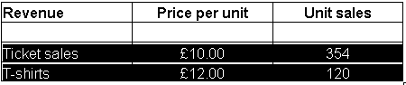
Then choose Edit > Copy, or right-click on the selection and choose Copy.

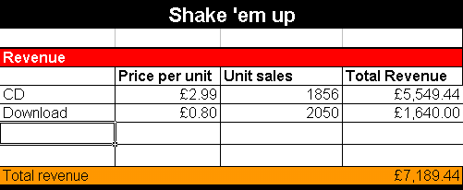
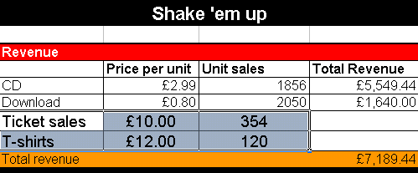
Then click in the top left-hand cell of the new cells you created on your spreadsheet, and paste. The data will be pasted into the cells to the right of and below the cell you select.

